6. PROJECT TESTING PHASE
Project Title:
Implement Client Script & UI Policy (Incident)
1. Introduction
Testing is performed to verify that the UI Policies and Client Scripts work correctly and produce the expected results.
2. Test Case 1
Test Objective:
Verify that the UI Policy is triggered when the specified condition is met.
Expected Result:
The field behavior changes according to the UI Policy configuration.
Actual Result:
The UI Policy was triggered successfully.
Status:
Pass
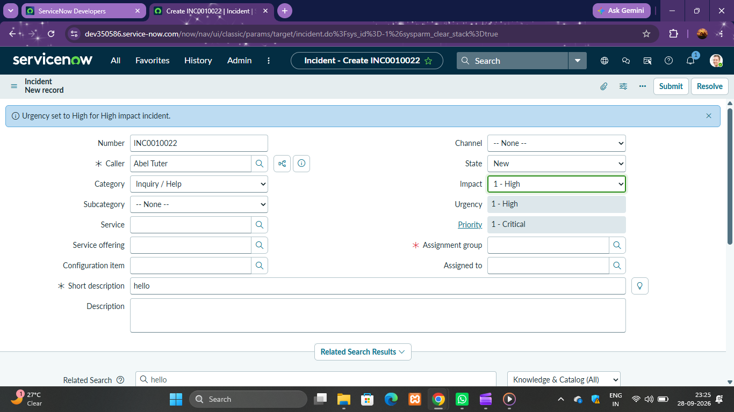

3. Test Case 2
Test Objective:
Verify the functionality of the onChange Client Script.
Expected Result:
The script should execute automatically when the field value changes.
Actual Result:
The script executed successfully.
Status:
Pass
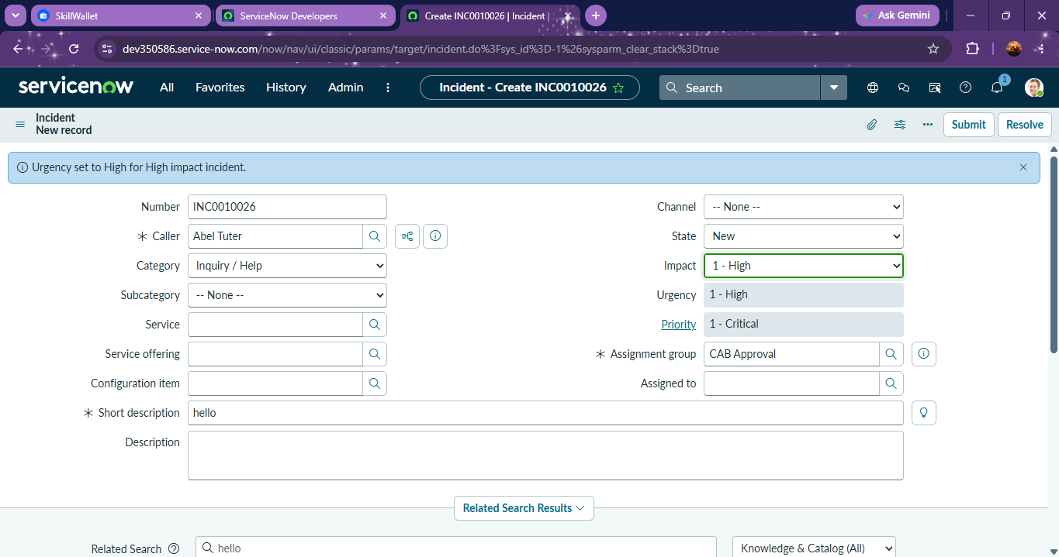

4. Test Case 3
Test Objective:
Verify the functionality of the onSubmit Client Script.
Expected Result:
The form should validate the data before submission.
Actual Result:
Validation was performed successfully.
Status:
Pass
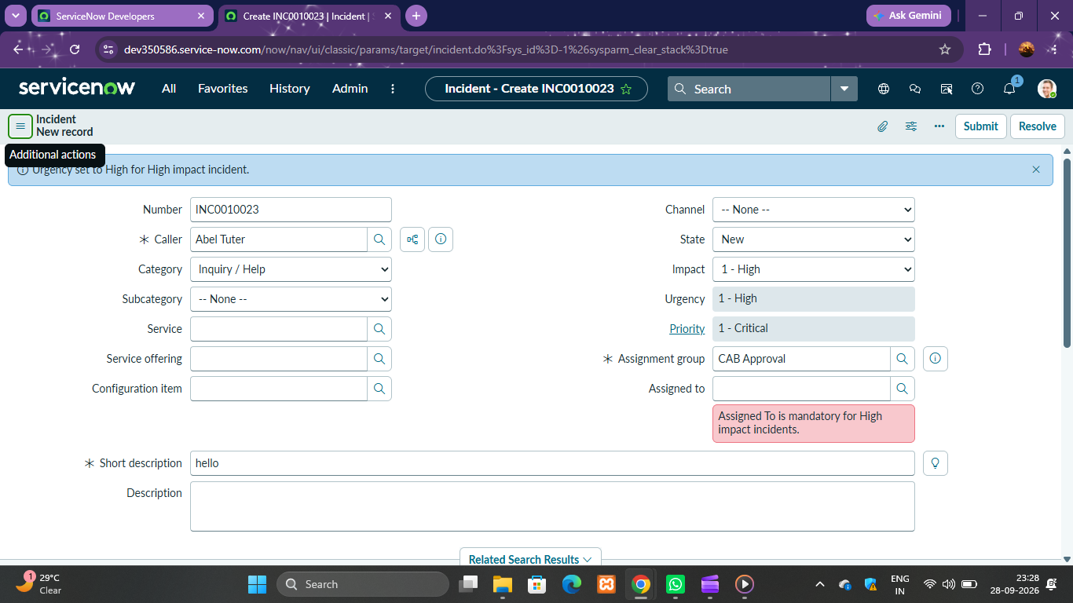

5. Test Case 4
Test Objective:
Verify the functionality of the onCellEdit Client Script.
Expected Result:
The script should validate data during list editing.
Actual Result:
The validation worked successfully.
Status:
Pass
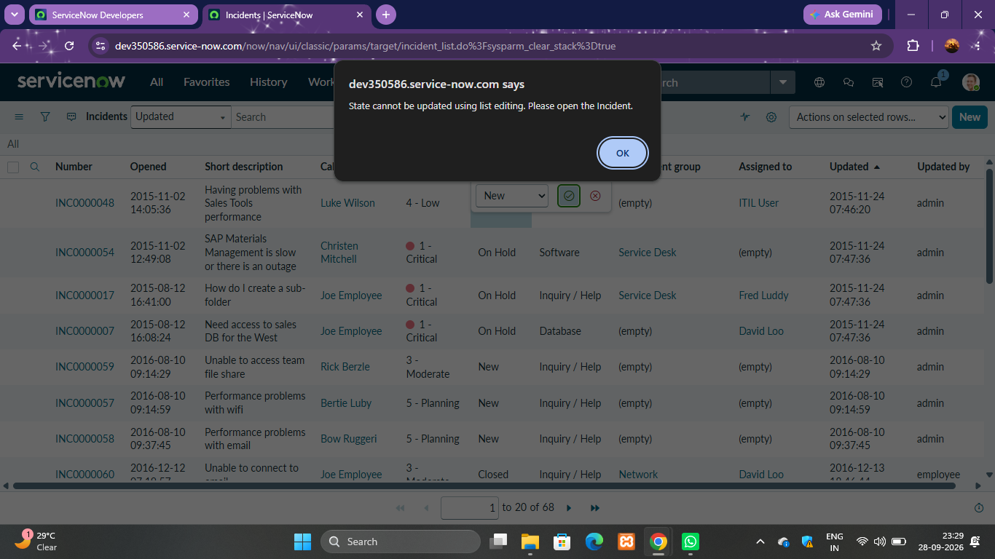
6. Testing Summary
All UI Policies and Client Scripts were tested successfully. The system performed as expected and validated user inputs correctly.
7. Conclusion
The project was tested successfully, and all functionalities worked according to the requirements.

